
Welcome!
Thank you for your interest in auditioning for our production of “Little Shop of Horrors” at the Area Community Theatre (ACT).
If this is your first time auditioning at ACT, we’re thrilled to have you! We’ve been around now for 50 years, and we wouldn’t have lasted so long without new people, new talent and new voices.
Whether you’re a veteran performer or you’ve never been on stage before but really want to try, we’d like to encourage you to audition for shows at ACT.
We’re aware that auditioning can be an overwhelming experience, even if you’ve done it a hundred times before. We’ve put this information packet together for you to help you learn a little more about the musical, the characters you will be reading for, and to give you some idea of what to expect during auditions and rehearsals.
Break a leg!
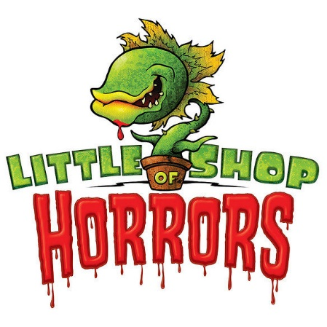
Lisa McCormick Theatre Manager & Director Area Community Theatre boxoffice@tomahact.com ACT Office: 608-374-7469 Cell: 608-377-3765

ABOUT THE MUSICAL

Little Shop of Horrors follows a hapless florist shop worker, Seymour, who raises a plant that feeds on human blood and flesh. The small plant wasn’t thriving in his new environment, until one day Seymour pricked his finger on a rose and a drop of blood falls into the plant, Seymour soon realizes the plant needs blood to survive. His co-worker, Audrey, whom he has a secret crush on, and his boss, Mr. Mushnik are thriving on the increase in business since the new plant, named Audrey II, begins growing larger and more popular. Meanwhile, Seymour must figure out how to keep up with the demand for blood. Audrey’s abusive boyfriend, Orin Scrivella, DDS, a sadistic dentist, encourages Seymour to take the plant and leave. Mr. Mushnik doesn’t want his shop to lose the business, so he offers to adopt Seymour and make him a full partner in the business. Meanwhile, Seymour must find a way to keep up with the demand from Audrey II and admit his love for the real Audrey. In the end, he loses it all, but Audrey II will keep on multiplying all across America!

Time Period: 1960’s

Duration: 2 Acts

Character Name GENDER PART SIZE VOCAL PART
Seymour Krelborn (Plant Owner) Male Lead Tenor
Audrey (Orin’s Girlfriend) Female Lead Mezzo-Soprano
Voice of Audrey II (Offstage) Male Supporting Baritone
Audrey II (puppeteer) Either Supporting Silent
Crystal (Skid Row Singer) Female Supporting Mezzo-Soprano
Ronnette (Skid Row Singer) Female Supporting Mezzo-Soprano
Chiffon (Skid Row Singer) Female Supporting Mezzo-Soprano
Orin Scrivello (Audrey’s Boyfriend) Male Supporting Baritone
Mr. Mushnik (Shop Owner) Male Supporting Baritone

Additional Characters that may or may not be cast depending on audition response:
Skid Row Wino Male Ensemble Bass/Baritone
Interviewer (Newspaper) Either Ensemble
Mrs. Luce (Life Magazine Owner, English) Either Ensemble
Skip Snip (W. Morris Agency, East Coast) Either Ensemble
Bernstein (NBC Studios Agent) Either Ensemble
Patrick Martin (World Botanical Gardens) Either Ensemble
Intro Voice Male Ensemble

PRODUCTION TEAM:
Lisa McCormick –lisaamccormick4@gmail.com
Director

Amy Kleespies - kleespiesa@veritaspress.com
Music Director

IMPORTANT DATES

AUDITIONS
Sunday, April 27, 2-5pm
Monday, April 28, 4-6pm
Tuesday, April 29, 4-6pm

CALLBACKS
Wednesday, April 30, 4-6pm

CAST POSTED
Friday, May 2nd by 12noon

FIRST REHEARSAL-REQUIRED ATTENDANCE BY ALL CAST & CREW
Monday, May 5, 5:30pm-8pm

REHEARSAL SCHEDULE
Rehearsal Period
May 5 – July 30
5:30-8pm – Monday – Thursday
Detailed rehearsal schedule will be distributed at first rehearsal
There will be additional rehearsals as we approach show dates
Can be adjusted based upon cast availability

TECH WEEK/DRESS REHEARSALS
July 7 – July 30
Crew integration, cue-to-cue, tech rehearsals. ATTENDANCE REQUIRED.
Possible additional and later rehearsals as we approach show dates

PERFORMANCES
July 31-August 3 & 7-10
Thursday, Friday, Saturday Shows at 7pm
Sundays at 1pm
Actors must be able to commit to all performance dates and tech/dress rehearsals

AUDITION INSTRUCTIONS
Area Community Theatre, Inc. is rooted in reflecting the community of Tomah through art and authentic storytelling. We recognize that to do that, every member of our community must be represented by our productions. We invite you to join us in providing art that challenges, entertains and represents us.

AUDITION TIME SLOTS
- Auditions are in 1 hour time slots.
- If you know of others auditioning, you can request to be together.
- Walk-ins are allowed as well; they will be funneled into the next open group audition time.
- Please sign up for a time in advance of auditions. (Contact Director if none of these times will work for you)
  - Sunday, 4/27 2pm, 3pm & 4pm
  - Monday, 4/28 4pm & 5pm
  - Tuesday, 4/29 4pm & 5pm

AUDITION PROCESS EXPECTATIONS:
- Turn in completed audition form to audition team
- Wait in hallway until called in for audition (will be called in groups)
- Introduce Yourself: Name & Grade/Age (if still in school)
- Head Shot (one of the audition team members will take your photo)
- Sing Prepared Song (verse and chorus only, accapella)
- Sing LSH Character Song (can use an accompaniment track)
  - Skid Row Girls – Skid Row (0:00-1:07) Downtown Lyrics | Little Shop of Horrors - YouTube
  - Audrey II – Git It (0:00-1:16) Levi Stubbs - Feed Me (Git It) (feat. Rick Moranis) (Lyrics)
  - Mushnik – Mushnik & Son (:49 – 1:47) Mushnik & Son (Complete Tracks with Guide Vocals)
  - Seymour – Grow For Me (:21 – 1:24) Little Shop Of Horrors - Grow For me - by Scott - YouTube
  - Audrey – Somewhere That’s Green (1:41-2:54) Somewhere that's green Little Shop of Horrors lyrics
  - Orin – Be a Dentist (:36-1:07) Little Shop of Horrors: Dentist! Lyrics! - YouTube
- Read from script shorts – Director will provide
  - Scenes based upon characters you are auditioning for and others
  - Reading for emotion, character and your general feel for the character
  - May not always be the character you are auditioning for

CALLBACKS: Callbacks will be by Director invitation only. The importance of callbacks is for the Director to look a little deeper at how individuals will work and sound together on stage. If you are not called for a callback, do not be alarmed, the Director may not need to call you back for another audition. Callback will include LSH Character Song (above) with a Performance Accompaniment Track (no words).

Callbacks are scheduled for Wednesday, April 30 from 4-6pm, although it is show week for Tomah High School, so if accommodations needs to be made, we may do Callbacks Sunday afternoon at the end of the day auditions to help with school/work conflicts. If you are unable to do your callback, please let the Director know and a special time can be arranged.

AGES: We are asking that all cast members be at least 16 years old due to the adult nature of the show content. All characters will be perceived and not necessarily the age of the actor, unless otherwise noted.

PUPPET/AUDREY II: The person who will portray the puppet, Audrey II, in puppet # 3 and 4 must be able to dead lift 100 pounds over their head. The puppet frame is very heavy and must be moved at quick and very slow rates of speed in time with the music and dialogue of the Audrey II character. The puppeteer will be a silent role in the show. The person who will portray Audrey II as the actor will not be the puppet also. This character would sing from off stage via microphone. It is essential that these two individuals work extra hard to get the timing right and may have additional rehearsals solely to work on timing.

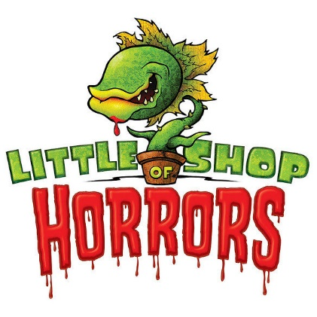

AREA COMMUNITY THEATRE AUDITION FORM

PLEASE COMPLETE THIS FORM, FILLING OUT ALL PORTIONS AND WRITE CLEARLY. YOU WILL NEED TO PRESENT THE FORM TO THE AUDITION TEAM PRIOR TO YOUR AUDITION.

NAME: ___________________________________ AGE: ____________ HEIGHT: ________

ADDRESS: _______________________________________ CITY: _________ ZIP: _________

CELL PHONE: _________________________ TEXT FRIENDLY: YES _______NO________

EMAIL ADDRESS: ____________________________________________________________

MAY WE OBTAIN A PICTURE OF YOU TODAY FOR THE PURPOSE OF CASTING THE SHOW? YES ________ NO _________

IS THIS YOUR FIRST AUDITION AT ACT? YES _________NO __________
IF SO, HOW DID YOU HEAR ABOUT US?

CHARACTER YOU ARE INTERESTED IN AUDITIONING FOR? _____________________

WILL YOU ACCEPT ANY ROLE ASSIGNED? YES ____________NO ____________

DO YOU HAVE ANY THEATRE EXPERIENCE? PLEASE LIST.

HAVE YOU TAKEN DANCE OR VOICE LESSONS? HOW MANY YEARS? WHO FROM?

IF NOT CAST IN THE SHOW, WOULD YOU BE INTERESTED IN VOLUNTEERING IN OTHER AREAS OF ACT?

STAGE MANAGER/CREW______ SOUND _____ LIGHTING ______ PROMPTER______

SET CONSTRUCTION ______ COSTUMES ______ MAKEUP ______ PROPS ______

PLEASE LIST ALL POSSIBLE CONFLICTS YOU WILL HAVE FROM MAY 5-AUGUST 10 (Vacations, Work, School, Church, etc.) :

